P095 Technology Optimization and Rationalization

Title | MS Fabric Architecture
Date Created | July 2026
Updated On
Updated by
Created By | Mike Scallion
DEPARTMENT | IT Engineering
Status | Draft

Contents
Purpose 4
Deployment Patterns 4
OneLake Features 4
Components 5
Four Level Hierarchy 6
Tenant Level 6
Capacity Level 6
Workspace Level 6
Item Level 6
Select a Deployment Pattern 6
Pattern 1: Monolithic Deployment 7
Pattern 2: Multiple Workspaces Single Capacity 8
Pattern 3: Multiple Workspaces Multiple Capacities 9
Pattern 4: Multiple Fabric Tenants 10
Capability matrix 10
Governance and administration 11
Security 11
DevOps and life cycle management 12
Performance and scale 13
Billing and cost management 13
OneLake Experiences 14
Data Factory 14
Synapse Data Warehouse 14
Synapse Data Engineering 15
Synapse Data Science 15
Synapse Real-Time Analytics 15
Power BI 15
Data Activator 15
Industry Solutions 15
Lakehouse vs Data Warehouse 15
Fabric Data Factory vs Notebooks 16
Data Factory Pipeline Scope 17
Bronze, Silver, Gold Data States 18
Fabric Lakehouse 18
Lakehouse Strategies 19
Lakehouses and GitHub Actions 20
Fabric Environments 21
Shortcuts 21
Passthrough vs Delegated Identities 21
Data Obfuscation 21
Fabric Oracle Mirroring 22
Force Logging 23
Sample Fabric Data Load and Transformation 24

Purpose
To document the Microsoft Fabric architecture and functionality, to assist in defining the BCPC Fabric solution architecture. Much of the information is from Microsoft’s documentation and AI search results.

Deployment Patterns
Structuring capacities, workspaces and items for BC Pensions organization.
https://learn.microsoft.com/en-us/azure/architecture/data-guide/technology-choices/fabric-deployment-patterns
https://arch-center.azureedge.net/fabric-deployment-pattern.vsdx

OneLake Features
https://youtu.be/J4i5lcROJcs?t=991
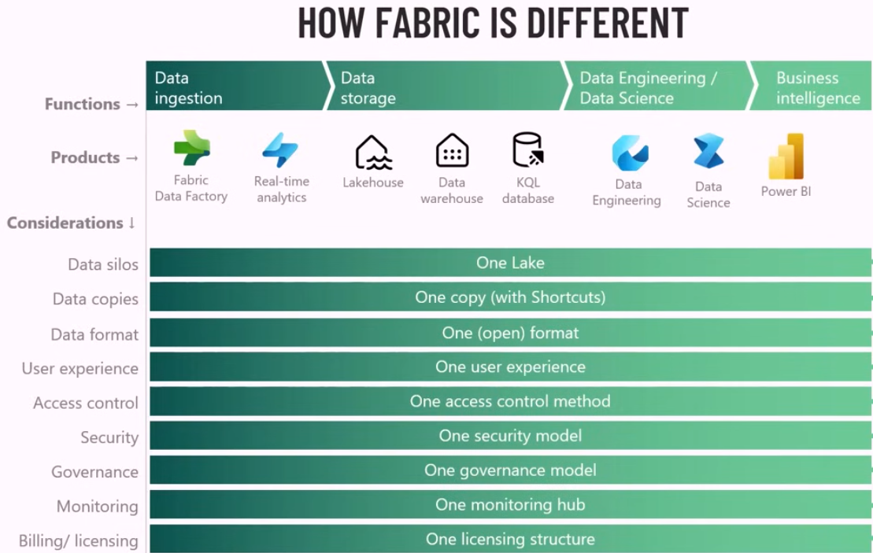

Components
- Microsoft 365 tenant: An identity and administrative boundary for your organization. It hosts Microsoft Entra ID (formerly Azure Active Directory) for authentication and authorization.
- Fabric capacity: A compute and billing resource used in a specific Azure region, for example East US or West Europe. To reduce costs, you can pause capacities when not in use.
- Fabric workspace: A collaboration container for Fabric items. It supports role-based access control (RBAC), Git integration, and deployment pipelines. For logical grouping, you can assign workspaces to Fabric domains.
- Fabric items: Data and analytics artifacts such as lakehouses, data warehouses, notebooks, pipelines, dataflows, semantic models, reports, and dashboards.
- Fabric domains: Logical groupings that organize workspaces by business unit or subject area. Domains support delegated governance and appear in the OneLake catalog for discovery and oversight.
  - When a workspace is associated with a domain, all the items in the workspace are also associated with the domain, and they receive a domain attribute as part of their metadata.
- OneLake: A unified, hierarchical data lake where tenants contain workspaces, which contain items. Fabric stores data in OneLake. OneLake supports Azure Data Lake Storage APIs, shortcuts to external storage, and integration with Data Lake Storage tools, such as Azure Storage Explorer and AzCopy.
- OneLake catalog: A centralized interface to find, govern, and secure Fabric data across the tenant. Users can access the catalog by using tools like Microsoft Teams, Excel, and Microsoft Copilot Studio.

Four Level Hierarchy
The deployment hierarchy flows from your Microsoft 365 tenant down to individual items. Your choice of deployment pattern determines how you use each level.

Tenant Level
Serves as the identity and administrative boundary for your organization.

Capacity Level
Each capacity is bound to a specific Azure region and has a specific F SKU that determines available compute resources measured in capacity units (CUs).

Workspace Level
Each capacity contains one or more workspaces. Workspaces are the primary containers for collaboration and governance. They define access control through four workspace roles (Administrator, Member, Contributor, and Viewer), support Git integration for version control, and serve as the scope for deployment pipelines.

Item Level
Workspaces contain Fabric items such as lakehouses, warehouses, notebooks, pipelines, semantic models, reports, and dashboards. Items inherit workspace permissions by default.

Select a Deployment Pattern
The following scenarios describe common business requirements and the deployment patterns that address them. Use these scenarios to help identify the pattern that best fits your organization.
- Scenario 1: Faster time to market with cross-team collaboration. If your organization wants faster time to market, cross-team collaboration, and lower restrictions on data usage, you can implement a monolithic deployment pattern. In this scenario, your organization operates in and manages a single workspace.
Use Pattern 1: Monolithic deployment.
- Scenario 2: Isolated team environments with central infrastructure management. If your organization wants to provide isolated team environments and a central infrastructure management team, you can implement multiple workspaces that use either a shared capacity or separate capacities. This scenario also suits organizations that want to implement a data mesh architecture.
Use Pattern 2: Multiple workspaces, single capacity or Pattern 3: Multiple workspaces, separate capacities.
- Scenario 3: Full business-unit autonomy over data platforms. If your organization wants an entirely decentralized model that gives business units or teams the freedom to control and manage their own data platforms, you can implement a deployment model that uses either separate workspaces with dedicated capacity or multiple Fabric tenants.
Use Pattern 3: Multiple workspaces, separate capacities or Pattern 4: Multiple Fabric tenants.
- Scenario 4: Hybrid approach that combines multiple patterns. If your organization wants a hybrid solution that uses multiple patterns to meet its requirements, you can implement a hybrid approach. For example, you might set up a single workspace for specific business units, like in a monolithic deployment pattern, and separate, dedicated workspaces and separate capacities for other business units.

Pattern 1: Monolithic Deployment
In this deployment pattern, you allocate one workspace for all use cases. All business units work within the same workspace.

Pattern 2: Multiple Workspaces Single Capacity
In this deployment pattern, you allocate multiple workspaces on a single shared capacity. Workspaces share that capacity, so concurrent workloads can affect the performance of jobs and interactive queries.

Pattern 3: Multiple Workspaces Multiple Capacities
In this deployment pattern, you allocate multiple workspaces across separate Fabric capacities, which provides governance and performance isolation between business units.

Pattern 4: Multiple Fabric Tenants
In this deployment pattern, all instances of Fabric are separate entities with respect to governance, management, administration, scale, and storage.
When to use this pattern
You might implement this deployment pattern if:
- Your organization has multiple Fabric tenants because of a business acquisition.
- Your organization wants to set up a Fabric tenant specifically for a business unit or smaller subsidiary.

Capability matrix
The following tables summarize the key differences in the capabilities of each pattern.

Governance and administration
Capability | Pattern 1: Monolithic | Pattern 2: Multiple workspaces, single capacity | Pattern 3: Multiple workspaces, separate capacities | Pattern 4: Multiple tenants
Governance complexity | Low | Medium | High | High
Per-department usage tracking | No | Limited ¹ | Yes | Yes
Domain-based delegation | No | Yes | Yes | N/A ²
Granular administrator delegation | No | Limited ¹ | Yes | Yes
Data residency compliance | Single region only | Single region only | Multiregion | Multiregion
Regulatory data isolation | No | Limited ¹ | Yes | Yes
1 Workspaces provide some isolation, but all workspaces share a single capacity, which limits the granularity of usage tracking and administration.
2 Pattern 4 uses separate tenants rather than domains. Each tenant has its own administration model.

Security
Capability | Pattern 1: Monolithic | Pattern 2: Multiple workspaces, single capacity | Pattern 3: Multiple workspaces, separate capacities | Pattern 4: Multiple tenants
Data plane isolation between teams | No | Yes | Yes | Yes
Control plane isolation (item-level access) | No | Yes | Yes | Yes
Workspace role boundaries between business units | No | Yes | Yes | Yes
Tenant-level security segregation | N/A | N/A | N/A | Yes

DevOps and life cycle management
Capability | Pattern 1: Monolithic | Pattern 2: Multiple workspaces, single capacity | Pattern 3: Multiple workspaces, separate capacities | Pattern 4: Multiple tenants
Deployment pipelines | No ³ | Yes | Yes | Yes
Git integration | Limited ⁴ | Yes | Yes | Yes
Independent releases per team | No | Yes | Yes | Yes
DTAP environment isolation | No | Yes | Yes (across capacities) | Yes (across tenants)
3 Deployment pipelines require separate workspaces, which aren't available in a monolithic single-workspace pattern.
4 Git integration is available but all teams share a single repository, which can create merge contention.

Performance and scale
Capability | Pattern 1: Monolithic | Pattern 2: Multiple workspaces, single capacity | Pattern 3: Multiple workspaces, separate capacities | Pattern 4: Multiple tenants
Workload isolation for performance | No | No | Yes | Yes
Multiple-geographic deployment | No | No | Yes | Yes
Scale beyond single SKU limits | No | No | Yes | Yes
Performance SLO guarantees | No | No | Yes | Yes
Throttling risk from shared capacity | High | High | Low ⁵ | Low
5 Throttling risk is low if workloads are on dedicated capacities, but throttling can still occur within a single capacity if demand exceeds available CUs.

Billing and cost management
Capability | Pattern 1: Monolithic | Pattern 2: Multiple workspaces, single capacity | Pattern 3: Multiple workspaces, separate capacities | Pattern 4: Multiple tenants
Centralized billing | Yes | Yes | No ⁶ | No
Per-team chargeback | No | No | Yes | Yes
Independent capacity pausing | N/A (single capacity) | N/A (single capacity) | Yes | Yes
Cost delegation to teams | No | No | Yes | Yes
6 Each capacity generates its own billing meter, so billing is distributed across capacities rather than centralized.

OneLake Experiences
https://youtu.be/J4i5lcROJcs?t=1161
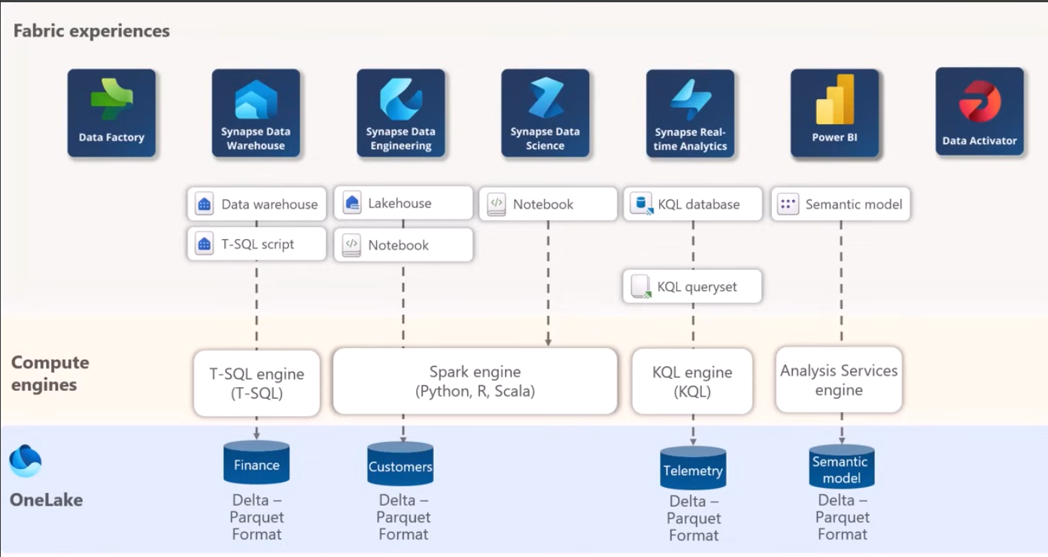

Data Factory
Moving and transforming your data. A set of tools to help you with Extract, Transform and Load.

Synapse Data Warehouse
Provides a familiar transactional data warehouse solution with tables, schemas, views, stored procedures, etc. Query-able using Structured Query Language (T-SQL).

Synapse Data Engineering
Enables users to design, build, and maintain infrastructures and systems that enable their organizations to collect, store, process, and analyze large volumes of data.

Synapse Data Science
Supports the entire data science workflow within and organization, from data exploration, preparation and cleansing to experimentation, modeling, model scoring and serving of predictive insights to BI reports.

Synapse Real-Time Analytics
Provides a set of tools to ingest, manage, and analyze real-time event data, ie security events log.

Power BI
Power BI is Microsoft’s business intelligence solution that allows you to create reports to present visual insights to business users.

Data Activator
Automatically taking actions (like running a Power Automate routine) when patterns or conditions are detected in changing data, such as data in Power BI reports and Eventstreams.

Industry Solutions
Get a head start with industry-relevant connectors, transformations and scenario-specific tools.

Lakehouse vs Data Warehouse
In Microsoft Fabric, the core difference is the engine: a Lakehouse uses Apache Spark (Python, Scala) for data engineering and machine learning, while a Warehouse uses T-SQL (SQL Server) for traditional business intelligence, reporting, and full read/write operations. Both store data physically in the same open Delta-Parquet format within OneLake.
Microsoft Fabric Lakehouse
- Core Engine: Apache Spark.
- Best For: Unstructured/semi-structured data (JSON, logs, images), machine learning, AI, and heavy data engineering.
- How It Works: You use Spark Notebooks (PySpark, Spark SQL) to ingest, transform, and clean raw data.
- SQL Endpoint: Automatically generates a read-only SQL endpoint, meaning you can query the data using T-SQL, but you cannot update or delete rows directly from the lakehouse interface.
- Key Feature: Can hold both processed tables and raw files in a single location.
Microsoft Fabric Data Warehouse
- Core Engine: Dedicated T-SQL Polaris engine.
- Best For: Traditional reporting, BI dashboards, structured data, and teams with strong SQL skills.
- How It Works: Acts exactly like a traditional SQL database or data mart. You use T-SQL commands (INSERT, UPDATE, DELETE, CREATE TABLE) directly within the warehouse.
- Key Feature: Supports full multi-table transactions, row-level security, and complex data modeling (star schemas).
How They Work Together
Because both engines point to the same storage layer (OneLake), you do not need to copy data between them. A very common architectural pattern is to use the Lakehouse to ingest and clean raw data, and then have the Warehouse consume that curated data for governed, high-performance business reporting.

Fabric Data Factory vs Notebooks
Microsoft Fabric Data Factory is a low-code/no-code orchestration tool used to move and manage data. In contrast, Fabric Notebooks are code-heavy (Python, Scala) tools designed for complex data transformation and machine learning. You use Data Factory to route data, and Notebooks to actually process it.
Key Differences
- Core Purpose: Data Factory focuses on orchestration, routing, and managing data pipelines (moving raw files into a Lakehouse or triggering a refresh). Notebooks focus on transformation, utilizing distributed Spark compute engines for advanced analytics, machine learning, and cleansing complex datasets.
- Skill Requirement: Data Factory is primarily visual and low-code, making it accessible to less technical users or data analysts. Notebooks require developer skills (Python, PySpark, R, or Spark SQL).
- Execution & Compute: Data pipelines orchestrate actions, while a Notebook executes logic on a Spark cluster. In fact, Data Factory often calls upon Notebooks as an activity within its pipelines to execute specific, heavy lifting.
Use Cases
- When to use Data Factory: When your primary goal is to extract data, load it (ETL/ELT), and manage dependencies. It is ideal for scheduling, looping through folders, sending notifications, and triggering semantic models
- When to use Fabric Notebooks: When you need customized API extraction, complex data deduplication, iterative algorithms, or need to run machine learning models directly on Microsoft Fabric OneLake data.

Data Factory Pipeline Scope
In Microsoft Fabric, the industry best practice is to build one dynamic, metadata-driven pipeline per subject area or business domain, rather than one per table. Hard-coding one pipeline per table leads to maintenance nightmares, whereas handling it per subject area keeps your workspace organized and highly scalable.
A subject-area approach uses looping and parameters to handle hundreds of tables dynamically, bringing several clear architectural advantages:
- Drastically Reduced Maintenance: You don't have to update 500 pipelines if you change your logging format or connection string. You make changes in just one place.
- Streamlined Security & Governance: Organizing your pipelines within logical Fabric Domains (e.g., Sales, HR, Finance) aligns with enterprise delegated governance and OneLake discovery.
- Consistent Batching: It is much easier to apply incremental refresh, watermark logic, and error handling uniformly to a single logical grouping of tables.
How to Implement the Subject Area Pattern
Instead of static copy activities, you orchestrate your pipeline using three primary components:
- Lookup Activity: Queries a control table or JSON configuration to retrieve a list of tables and schemas specific to that subject area.
- For Each Activity: Iterates over the array of tables returned by the Lookup activity.
- Copy Activity / Data Flow Gen2: Executes within the loop. By using dynamic content (e.g., @item().TableName), it processes and writes the data to the correct Delta table in your Lakehouse or Warehouse.
- When to use 1 Pipeline per Table
- Streaming or Real-time Data: If a specific table requires sub-minute ingestion or relies on event-driven streaming (via Eventstream), it should be isolated.
- Massive Complexity: If a table requires exceptionally heavy, multi-step transformations and business rules unique to that data (e.g., complex Python notebooks), separating it allows for dedicated compute optimization

Bronze, Silver, Gold Data States
The Data Layers: Bronze, Silver, Gold (Data State)
This framework—popularized in cloud architectures like Azure Databricks or Microsoft Fabric—measures how far raw data has been transformed:
- Bronze (Raw): Stores unstructured/structured source data exactly as it arrives. It is used for historical archiving, auditing, and allows for zero-loss data recovery.
- Silver (Cleaned): Filters, standardizes, and deduplicates the Bronze data. This creates a reliable, normalized dataset that multiple teams can trust.
- Gold (Business-Ready): Formatted into project-specific aggregates, dimensions, and facts optimized for specific reports, dashboards, or AI/ML consumption.

Fabric Lakehouse
https://youtu.be/Av44Nrhl05s?t=340
When you create a lakehouse in Microsoft fabric, you're essentially setting up an environment that consists of several key components.
- The lakehouse itself is the central data repository. It's built using the lakehouse architecture which combines the best features of data lakes and data warehouses. It stores structured and unstructured data and it's optimized for large scale data storage and high-performance BI analytics.
- The SQL Analytics endpoint provides an SQL based interface to execute queries on the data stored in the lakehouse. It enables users to perform data exploration, generate reports, and conduct analytical tasks using the familiar SQL syntax and editor interface.
- The semantic model is a layer that defines the business logic and relationships within the data. It provides a structured and understandable view of the data to enable deeper analysis. This semantic model is typically a star schema, and it's created automatically for you. It enables downstream analytics for business intelligence, and it's kept in sync with no user intervention.

Lakehouse Strategies
In Microsoft Fabric, the choice between using One Lakehouse vs Lakehouses per Domain centers on whether your organization is centralized or decentralized. A single lakehouse simplifies management for small teams, whereas a domain-based model scales better for larger, decentralized, or domain-driven organizations.
The comparison below breaks down the architecture, administration, and use cases for both approaches:
Single Lakehouse Strategy
A single, centralized lakehouse houses all of your data. Data layers (Bronze, Silver, Gold) are separated via multiple schemas within that single lakehouse.
- Best For: Small-to-medium teams, centralized BI departments, or organizations starting in a Microsoft Fabric trial/pilot phase.
- Architecture: Uses one primary lakehouse object. Distinct data transformation stages are defined by schemas (e.g., bronze.sales, silver.sales).
- Pros: Extremely easy to set up. Requires minimal cross-workspace governance or complex security architecture.
- Cons: High risk of accidental data access by unauthorized users. As data scales, managing permissions at the table and schema levels becomes difficult due to a lack of physical separation.
Domain-Based Strategy
This setup aligns with a data mesh architecture. You designate separate lakehouses or workspaces for distinct business departments (e.g., "Finance", "Marketing", "Supply Chain").
- Best For: Large enterprises, highly decentralized teams, and organizations that require strict federated governance and ownership over data products.
- Architecture: Departments have their own dedicated workspaces mapped to specific Domains in Microsoft Fabric. Data is securely shared across domains using OneLake Shortcuts to prevent physical data duplication.
- Pros: Clear data ownership. Provides a clear "blast radius" for security and compliance. Teams can maintain and deploy their own pipelines without affecting other business units.
- Cons: Demands high organizational maturity. Requires upfront governance, change management, and domain stewardship to succeed.

Lakehouses and GitHub Actions
When integrating a data platform (like Microsoft Fabric) with GitHub Actions or other CI/CD pipelines, using multiple lakehouses (typically three—Bronze, Silver, and Gold) mapped to one central workspace is the standard best practice for CI/CD.
This architecture provides optimal control, security, and scalability for version control:
Why Multiple Lakehouses?
- Medallion Architecture: Separate your raw data (Bronze) from cleansed data (Silver) and business-ready aggregated data (Gold).
- Granular Security: Restrict downstream consumers (Gold) to specific read-only tables without granting them access to raw, unvalidated sources (Bronze).
- Clear State: It prevents data contamination and isolates pipelines, making debugging failed GitHub Actions significantly easier.
Why a Single Workspace?
- Simplified Git Syncing: Git integration (like in Microsoft Fabric) maps exactly one workspace to one Git branch (e.g., main or dev).
- Native Deployment Pipelines: Keeping all layers (Bronze/Silver/Gold) in one workspace allows you to use built-in deployment pipelines to seamlessly promote all three layers across Development, Test, and Production stages.
- Resource Sharing: Notebooks, data pipelines, and semantic models can dynamically interact with multiple lakehouses seamlessly in the same environment.
⚠️ Important CI/CD Caveat
- Metadata vs. Data: Git integration tracks metadata (pipelines, notebook code, schema definitions), but not the actual data.
- Auto-binding: When you promote notebooks across different environments via GitHub actions, ensure your CI/CD processes utilize auto-binding to map the notebooks to the correct environment-specific lakehouse.

Fabric Environments
Microsoft Fabric environments provide flexible configurations for running your Spark jobs. So in an environment, you can select different Spark runtimes, configure your compute resources, and install libraries from public repositories or upload custom built-in libraries.

Shortcuts

Passthrough vs Delegated Identities

Data Obfuscation
< AI results placeholder >
Data obfuscation in Microsoft Fabric involves protecting sensitive information by masking, encrypting, or replacing raw PII (Personally Identifiable Information) with realistic but fictional data. This allows teams to safely develop, test, and build analytics without exposing real-world data or violating compliance regulations.
Depending on your architecture, you can handle data obfuscation in Fabric through several primary methods:
1. Dynamic Data Masking (DDM)
- How it works: Masks data directly at the query level. The underlying data in the storage remains untouched, but unauthorized users see masked values (e.g., XXX-XX-1234 for Social Security numbers).
- Where to use: Best for Data Warehouses and SQL Analytics endpoints in Fabric using T-SQL.
- Actionable Link: Review the official DDM guide on Microsoft Learn.
2. Notebook-Based Obfuscation (Landing Zone to Bronze)
- How it works: Ingest raw data into a restricted, secure Landing Zone workspace, apply obfuscation logic (encryption, partial/full masking, or tokenization) using Spark notebooks, and then expose the clean, obscured data to the Bronze layer via shortcuts.
- Where to use: Best for Lakehouse environments where pipelines process raw data before downstream consumption.
3. Third-Party API Integration (Delphix)
- How it works: Automates the masking of complex datasets before they reach Fabric using pre-built algorithms.
- Where to use: Best for Data Factory dataflows.
- Actionable Link: Follow the integration steps on Microsoft Learn.
4. OneLake Security & Sensitivity Labels
- How it works: Apply built-in Microsoft Purview information protection. You can set rules using Column-Level Security (CLS) or Row-Level Security (RLS) to restrict access based on user credentials.
- Actionable Link: Explore workspace and OneLake governance on Microsoft Learn.

Fabric Oracle Mirroring
Supplemental Logging must be enabled on the Oracle database to support Fabric mirroring. We will investigate using minimal supplemental logging to reduce the resource requirements on the Oracle server.
https://docs.oracle.com/database/121/SUTIL/GUID-D2DDD67C-E1CC-45A6-A2A7-198E4C142FA3.htm#SUTIL1583
Database-Level Supplemental Logging
There are two types of database-level supplemental logging: minimal supplemental logging and identification key logging, as described in the following sections. Minimal supplemental logging does not impose significant overhead on the database generating the redo log files. However, enabling database-wide identification key logging can impose overhead on the database generating the redo log files. Oracle recommends that you at least enable minimal supplemental logging for LogMiner.
Enable supplemental logging for the database:
ALTER DATABASE ADD SUPPLEMENTAL LOG DATA;
ALTER DATABASE ADD SUPPLEMENTAL LOG DATA (PRIMARY KEY, UNIQUE) COLUMNS;
Grant these permissions to your sync user:
GRANT CREATE SESSION TO user;
GRANT SELECT_CATALOG_ROLE TO user;
GRANT CONNECT, RESOURCE TO user;
GRANT EXECUTE_CATALOG_ROLE TO user;
GRANT FLASHBACK ANY TABLE TO user;
GRANT SELECT ANY DICTIONARY TO user;
GRANT SELECT ANY TABLE TO user;
GRANT LOGMINING TO user;

Force Logging
Another consideration is FORCE LOGGING. Per the Oracle GoldenGate documentation, Oracle recommends setting the database to force logging. An alternate solution is to modify any IPASP tables that are currently set to nologging, to enable logging.
https://docs.oracle.com/en/middleware/goldengate/core/19.1/coredoc/enabling-minimum-database-level-supplemental-logging_19c.html
Oracle strongly recommends putting the Oracle source database into forced logging mode. Forced logging mode forces the logging of all transactions and loads, overriding any user or storage settings to the contrary. This ensures that no source data in the Extract configuration gets missed.
Per DEV3;
Connected to Oracle Database 19c Enterprise Edition Release 19.0.0.0.0
Connected as mscallion@dev3_tpurgent
--
SELECT force_logging FROM v$database;

FORCE_LOGGIN
------------
NO
--
select owner, count(*)
from dba_tables
where logging = 'NO'
and owner in (
'CRMUSER','IPASORDS','IPASUSER',
'PNFXMMBR','RMSUSER','SPLUSER')
group by owner
order by owner;

OWNER COUNT(*)
------------ ----------
CRMUSER 3
IPASORDS 1
IPASUSER 7
PNFXMMBR 32
RMSUSER 36
SPLUSER 1

6 rows selected

Sample Fabric Data Load and Transformation
YouTube: End to End Data Project with Microsoft Fabric - Data Engineering, Data Factory and Power BI
https://www.youtube.com/watch?v=Av44Nrhl05s
Lakehouse: Build a lakehouse which also creates a semantic model and an SQSL endpoint.
Bronze: Build a notebook that consumes json data from a URL, with date parameters, and creates a json file.
Silver: Using the bronze json file, build a notebook that consumes the above json file and extracts the elements that are required and creates a data set, and appends it to the silver table.
Gold: using the silver table, build a notebook to add attributes using an external library, which required a new environment. Append the data to the gold table.
Power BI: Build a Power BI report using the semantic model directly. Add the gold table to the semantic model.
Pipeline: Build a data factory pipeline that loads the data into the gold table by executing the bronze, silver and gold notebooks. Pass in the date parameters.

